Governors Report

In English year 3 have been learning about Persuasion. Here they are trying to persuade Mr Booth to either have a bar of chocolate or an apple.
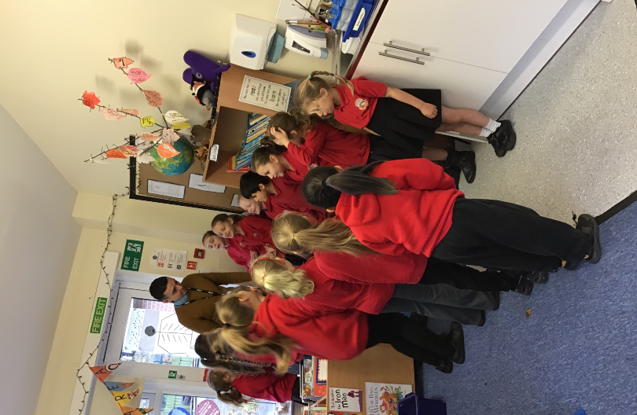

In History, year three have been learning all about local History. But before we get into the specifics, we needed to know where the Victorians fit into a chronological timeline.
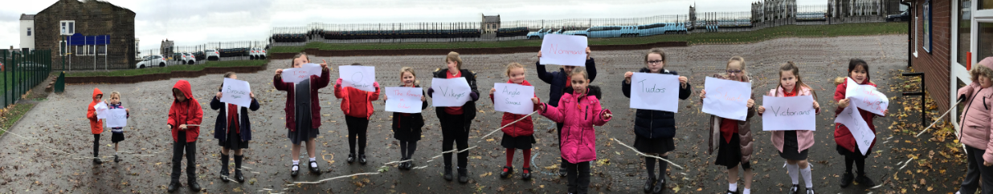

In Art and DT, year three have been making Lancashire Wheels, which blends Art and DT together to create a Lancashire Landscape through weaving and painting.
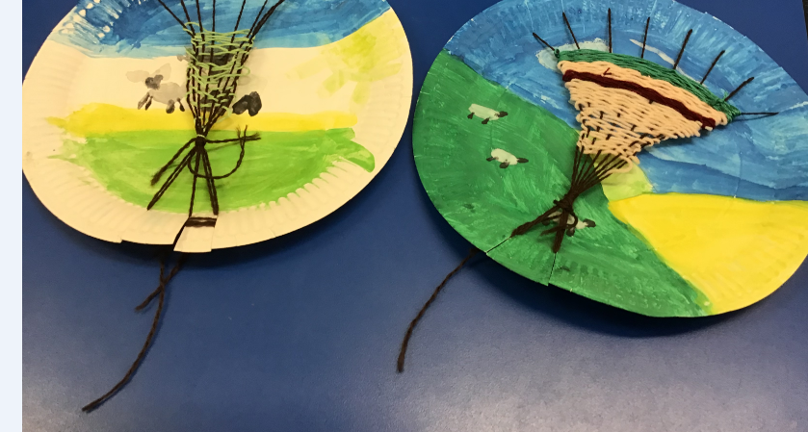

In Science year three have been exploring light. Here they are testing how shiny certain materials are.
